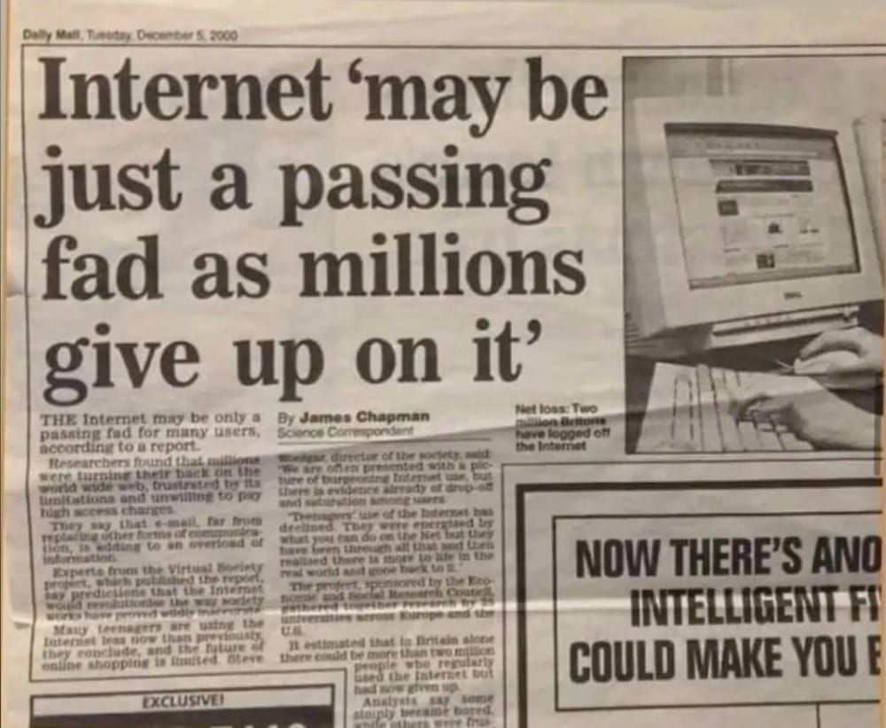
Dear GenZ Human,

The next time someone tries to call you a snowflake, show them this article and tell them that you live in an era that is defined by information itself- while they were getting overwhelmed by puny E-mails.

"Information overload" to them was their spammed mailbox when you as a human are informationally attacked every second of your life.

You need a mental health break because you have to constantly react to a world that changes colours like a chameleon- designed by people who did not have to grow up in it.

You live in an era where virtual reality masks systemic failures- an era in which unemployment rates can go from 6% to 30% within a span of months and back.

The report-making processes of institutions and the surveys are too slow to really capture the pace of adaptation you have to undergo- and why wouldn't they be, when the process itself was created for their times?

A study done over a period of 40 years (1952-1993) showed that "normal children" in schools during the 80s experienced more anxiety than child psychiatric patients did in the 50's.

( https://lnkd.in/gsyiTHbU )

Those 80s kids, living in their social, political, and economic realities, believed that it was the baseline.

Maybe, they crafted a world in that image, and expect the same to carry on.

It is not their fault, but the fact that you are aware that it is not "normal" or "right" is reflective of how you mark a significant evolutionary milestone for our species.

Keep taking those mental health breaks, keep switching roles with your partner when needed, and allow that flexibility- you're doing something right, you're doing something no generation other than the one which laid the foundational stones of our species did.

( https://lnkd.in/gzcxVm-s )

You recognize we need a collaborative, and not competitive world.

You realise you need to function at your best to really make a difference, and it requires taking care of oneself. Without that, it is not sustainable.

Today's world is built on things the largest part of their world couldn't even believe in, how do you expect them to understand its consequences?

It is not their fault- their learning and their tactics to survive were different. They wish the best for you. You are their children, nephews, and proteges, it only happens so that your generation has to figure out how to live, work and thrive, all over again.

Listen to all, but know that only you know your life best.

Love,

Fellow GenZ being.

